Hypothesis Tasting

When a chef is starting out with a new dish, he has to understand what the current menu is missing. He needs to figure out what dish can complete the selection or replace what is being removed.

As data scientists, we need to start with a question as well. Usually it comes through business understanding. We need to figure out what opportunities can create the greatest value for our organization.

Ingredients = Data

After the chef has determined what type of dish he would like to make, he goes to the fridge to gather ingredients. If he doesn’t have the necessary ingredients, he takes a trip to the store to collect them.

As data scientists, our data points are our ingredients. We may have some on hand, but we still might have to collect more through web scraping, SQL queries, etc.

Much like raw ingredients, data isn’t usually very useful on its own. Once we have combined our data and analyzed it, we eventually find its true value. Salt isn’t generally consumed by itself, but almost every meal would be lacking without it.

Wash your food and your data

Food can be covered with dirt, pesticides, or other hazardous matter. It is important to wash ingredients before consuming them to avoid bad flavors and illness.

It is also important to our clean data. Poor quality “dirty” data can produce disastrous results for our models. Admittedly, the way we clean data is a little different than how a chef cleans vegetables. We need to focus on cleaning up data types, imputing null values, and removing outliers.

Flavor engineering

Sometimes chefs need to adjust the composition of their ingredients before putting them into their dish. They crack eggs, chop onions, and portion meats before cooking them.

This process closely mirrors feature engineering in data science. Sometimes we need to change our data so that it will produce the best results for our models. We can group our data, scale it, encode it, or transform it. These changes can help to improve the interpretability and accuracy of our output.

Taste and explore

When cooking from scratch, most chefs taste their food as they go. They need to understand the flavor profile of each ingredient and how the ingredients will likely taste together. After understanding these relationships, they will be able to determine which ingredients to include in the final meal.

For data scientists, it is also important to explore our data before we build our model. We have to understand the relationships between our variables to avoid multicollinearity (in some models).

Sous Vide = Deep Learning?

After a chef assembles his ingredients, it is time to choose how to cook the meal. There are many cooking options available, he can choose to bake, broil, boil, sautee, grill, sous vide … you get the point. Based on what he is cooking, he likely knows which of these options will produce the best result.

This is not unlike our model selection. We know based on the problem we are trying to solve (regression, classification, or clustering) which models might be best, but we still have to narrow it down from there. It is in our best interest to try a few of them to see which one produces the best result.

Tune your oven

Chefs are not done once they choose a cooking medium. They still have to figure out how long to cook their meal and at what temperature. These variables are integral to the success of the meal.

This bares resemblance to the model tuning process for a machine learning model. We have to make some tweaks to our algorithms to make sure that we are getting the best result. Unfortunately, I don’t think there is gridsearch for cooking methods… yet.

Tasty cross validation

Our chef has finished cooking his meal, but he still isn’t done! He needs to review the results. He wants to make sure that it isn’t just him who finds it delicious. It is important for him to have the other chefs in the kitchen taste the dish. If he caters only to his taste, his meal may not have the broad appeal that he is hoping for.

This is much like the cross validation process in data science. We want to make sure that our model generalizes well, so we test it on new data and compare the results.

Art of plating

If the food meets an acceptable standard, it is important to make it appealing when it is plated. Plating the food adds to the sensory experience of the chef’s guests.

In data science, we have to explain our models to business stakeholders. We have to produce beautiful visualizations that add to the understanding of our work.

Both plating and data visualization could be considered their own fields because of their tremendous depths.

Document your flavors

Finally, if the chef likes the result and would like to reproduce the meal, he needs to write down a recipe. He should also train the other chefs in the kitchen to produce this same result.

For data scientists, it is important to document our code and to build systems to repeatedly execute our model.

In cooking and data science, reproducibility is fundamental for long term success.

Your kitchen should be an API

When operating a restaurant, it is important for the process to be extremely simple for the customers. They should be able to order a meal, and the meal should be delivered to them consistently. They don’t have to know how the meal is cooked, what the chefs are doing, or even what is going on in the kitchen.

This is how a model API endpoint should work in data science. You should be able to send it a request (order), and get a reliable response (meal) without having to worry about how the sausage gets made.

[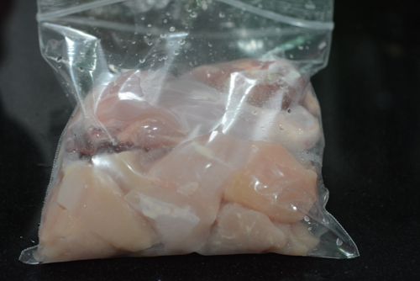](https://www.cookingandme.com/wp-content/uploads/2016/01/Hyderabadi-chicken-dum-biryani-chicken-dum-biryani-recipe-3-2.jpg)

In a blender or mixer jar, add all the ingredients needed for marination + salt. Grind coarsely.

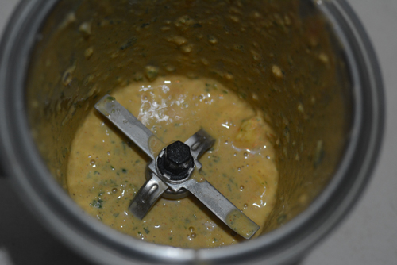

Add to the chicken pieces, mix well, and leave to marinate in the refrigerator for about 8 hours or overnight

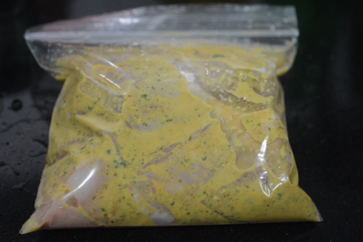

Next morning, wash and soak 1 cup basmati rice in enough water to completely cover it for 30 minutes

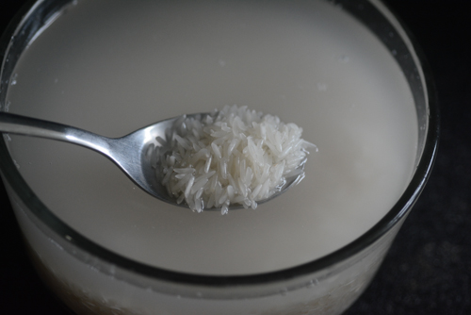

In the meantime, chop your onions

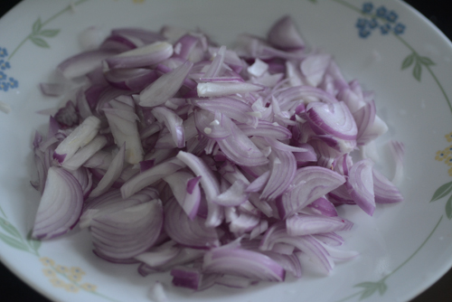

and powder the spices for biryani masala coarsely

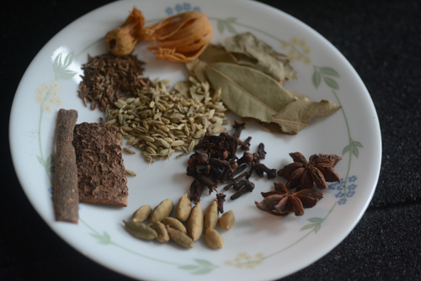

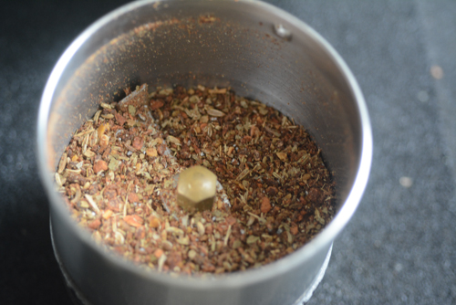

Soak a pinch of saffron in 3 tbsp warm milk and set aside

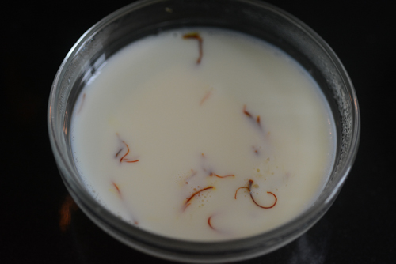

Heat 1/4 cup ghee in a heavy-bottomed pan with a tight-fitting lid. This is the same pan we will use to cook the dum biryani

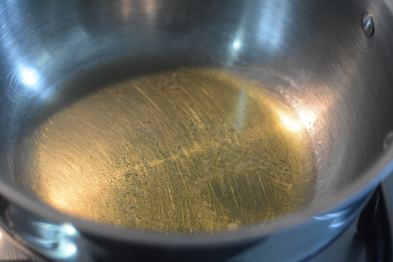

Add the sliced onions and keep flame at medium-low. Stir frequently to ensure even frying (ignore that the pans are different, I made vegetable dum biryani and chicken dum biryani simultaneously and did a bunch of prep work in conjunction)

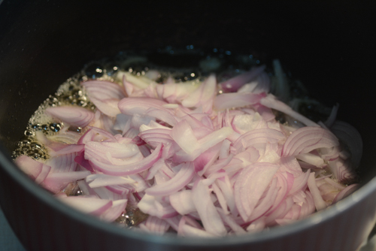

While the onions are frying, keep water in a large pot for cooking the rice. Bring the water to a rolling boil and add 1 tsp caraway seeds (shahjeera), 2 bay leaves, 1 tsp oil, and some salt

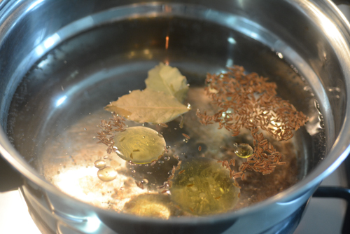

Add the soaked rice to this.

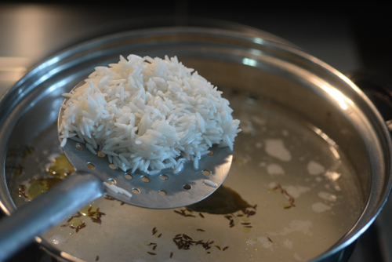

Cook on medium-high heat until the rice is 3/4 cooked. When you take out one grain and bite into it, it shouldn’t be mushy or cooked fully

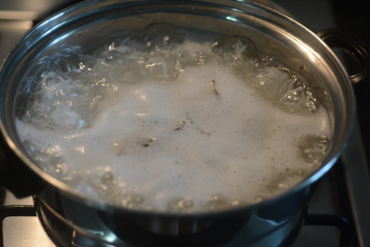

While the rice is cooking, keep an eye on the onions and drain when they are fully dark brown

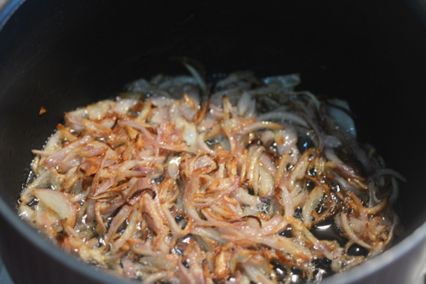

In the same ghee, fry the cashew nuts, drain and then fry the raisins and drain.

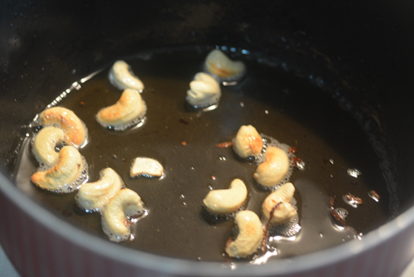

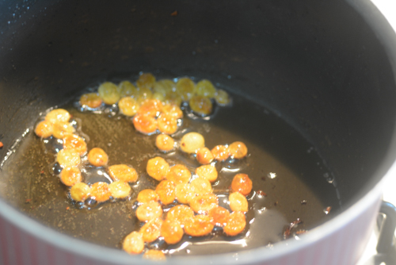

Set aside until needed.

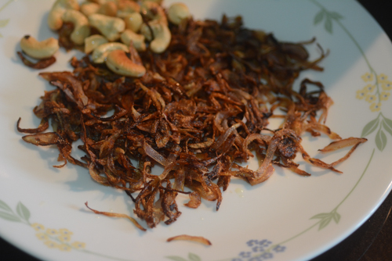

The rice should now be done. Drain the rice in a colander and fluff it with a fork

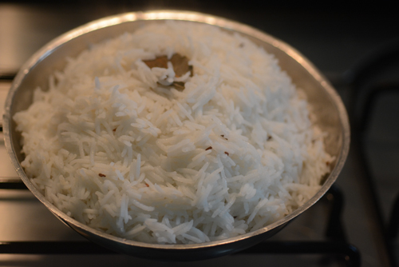

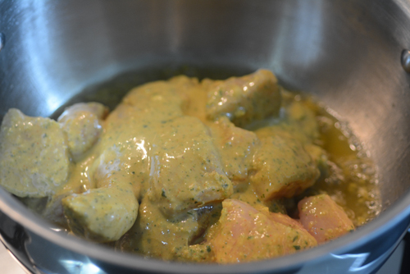

Now, in the same pan used for frying the onions, top up the remaining 1/4 cup ghee (see notes). Add the marinated chicken pieces and mix well.  
Let this cook for 30 seconds. Then add the freshly ground whole spices spices or biryani masala and fry for another minute or so.

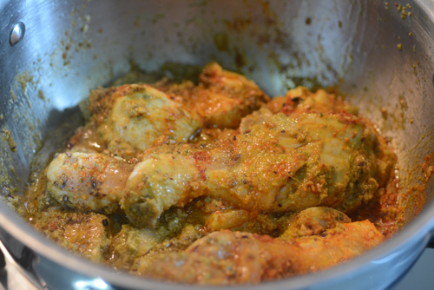

Add 1 tbsp each of chopped coriander leaves and mint leaves on top. Mix well to combine.

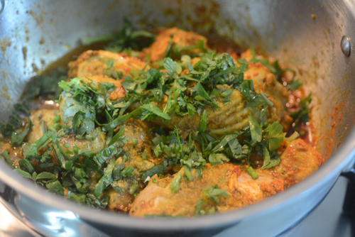

Layer the cooked rice over the chicken. Yes, the chicken is still raw, our dum cooking will cook it perfectly in about 15-20 minutes so this is fine.

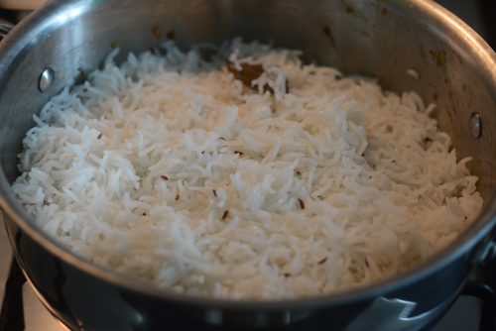

Top up with fried onion, cashew nuts, raisins, coriander leaves, and mint leaves

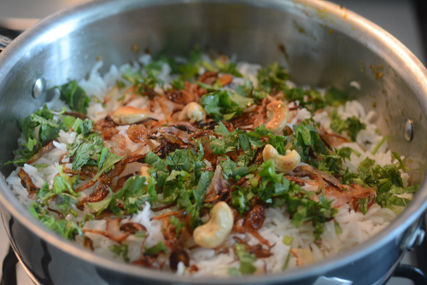

Pour the saffron milk mixture on top

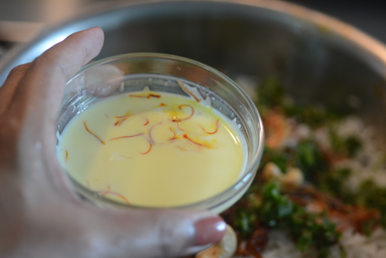

There are different methods to ensure we provide a dum cooking environment for the biryani. I used aluminium foil and closely covered the cooking pan, taking care of the handle area first

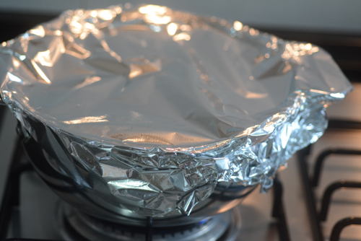

Then, I closed the pan tightly with its lid

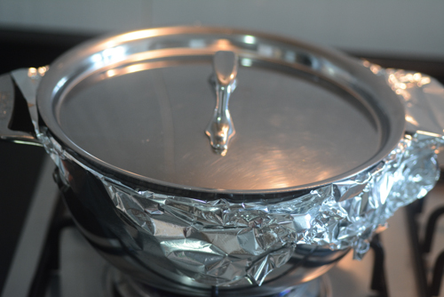

Keep the heat to lowest possible and cook for about 15-20 minutes. Since the lid wasn’t super tight, I placed some weight over it.

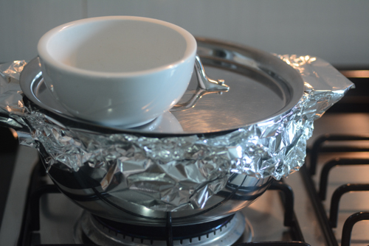

Cook on very low flame for 15-20 minutes.

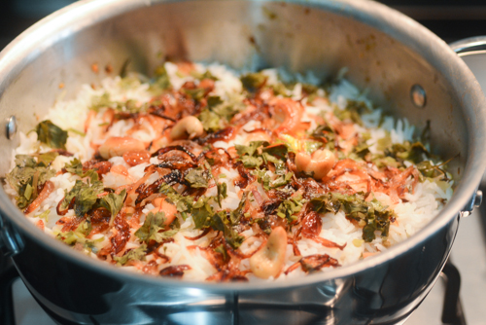

Once done, uncover and gently combine the layers so that the spices get mixed with the rice

